**Virtual Machine Installation Steps**

1. Click on the below link to install virtual machine

<http://www.oracle.com/technetwork/database/enterprise-edition/databaseappdev-vm-161299.html>

1. Scroll down and click accept

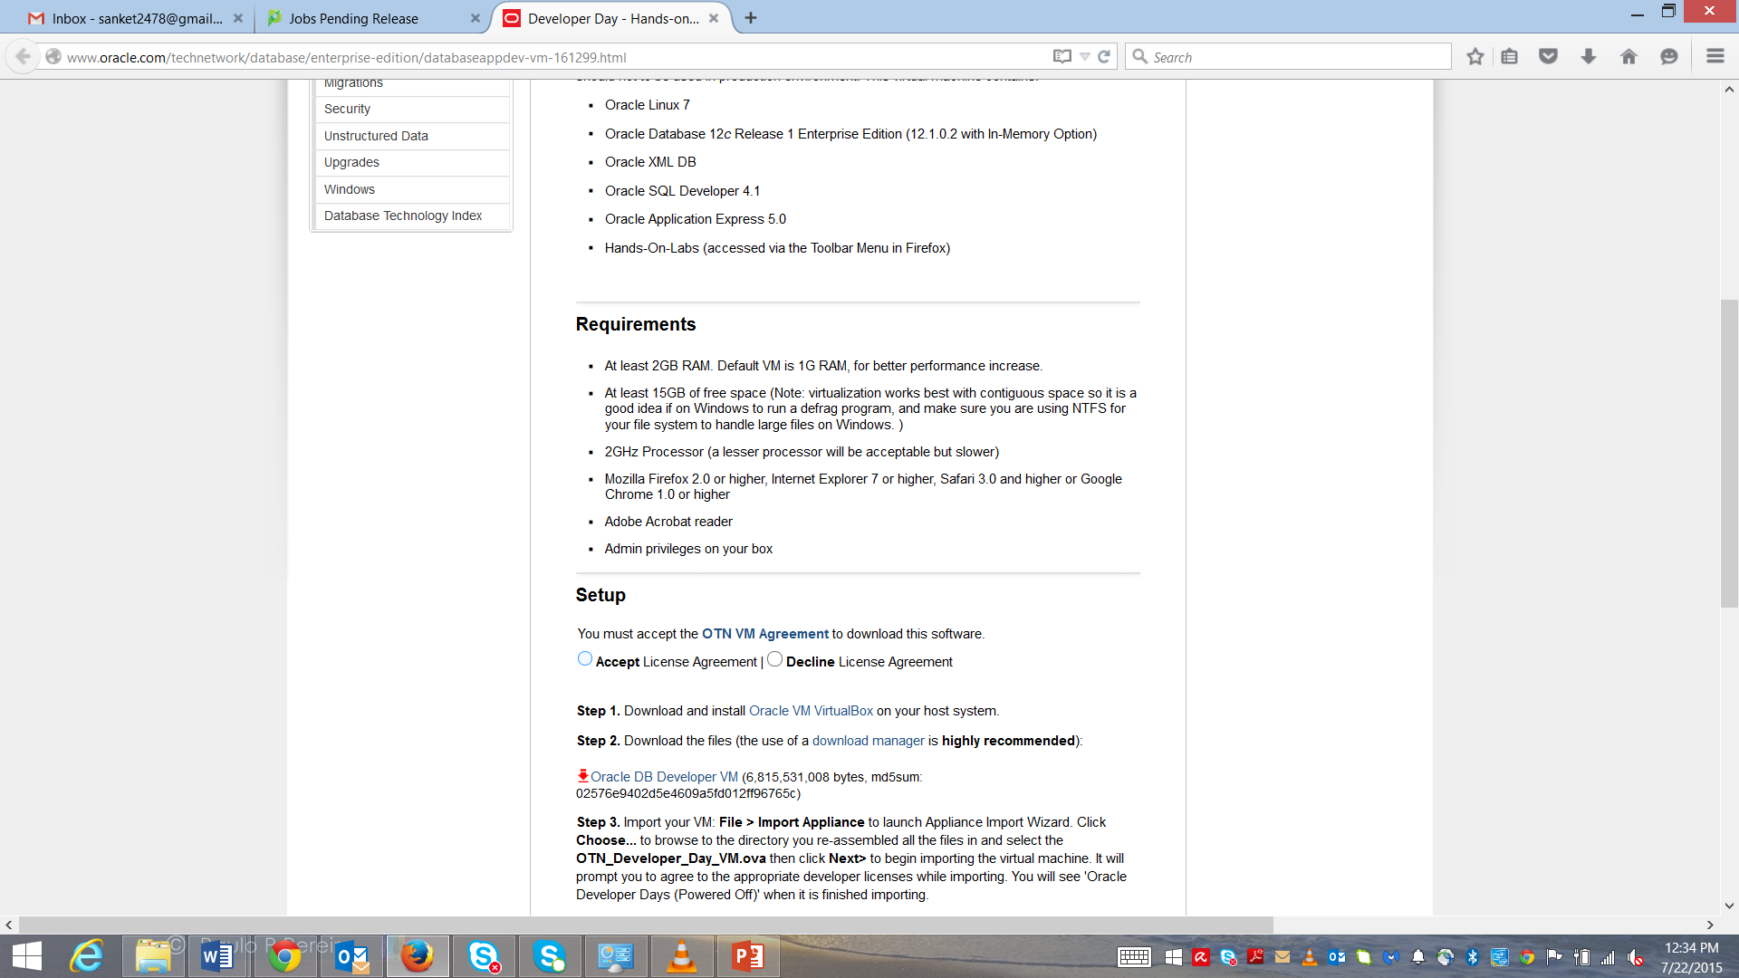

1. First click on “Step1: Download and Install **Oracle VM Virtual Box** on your host system”
2. Then click on “Platform Windows (32-bit/64-bit) Installer” depending on your OS. Mac users need to click on “Mac OS X”.

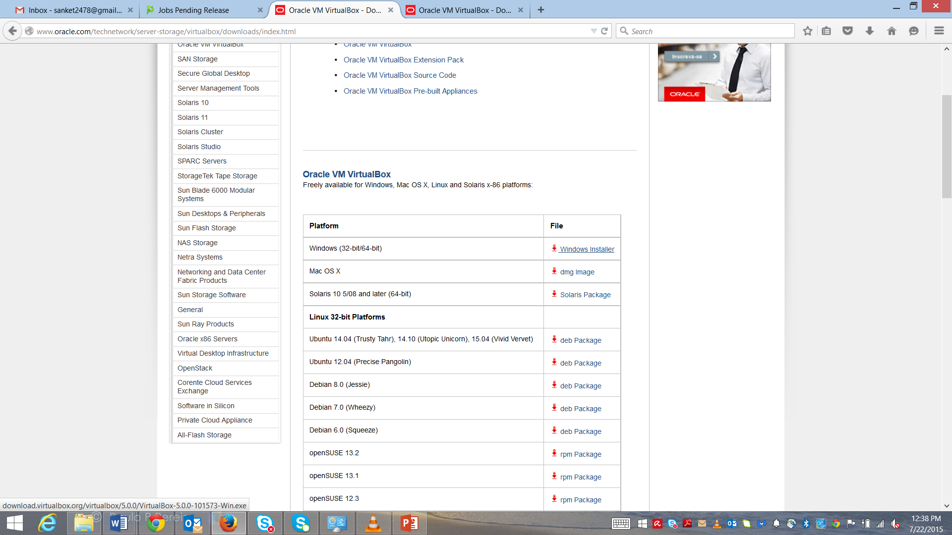

1. After the installation is complete click on the “Step2: Oracle DB Developer VM” to download the OTN_Developer_Day_VM.ova file”

(Note: you will need to create an account on Oracle to install this file)

1. Open the Oracle VM to import your VM: **File > Import Appliance** to launch Appliance Import Wizard. Click **Choose...** to browse to the directory you re-assembled all the files in and select the **OTN_Developer_Day_VM.ova** then click **Next>** to begin importing the virtual machine.
2. This will automatically load the .ova file into the virtual machine which has all the data.

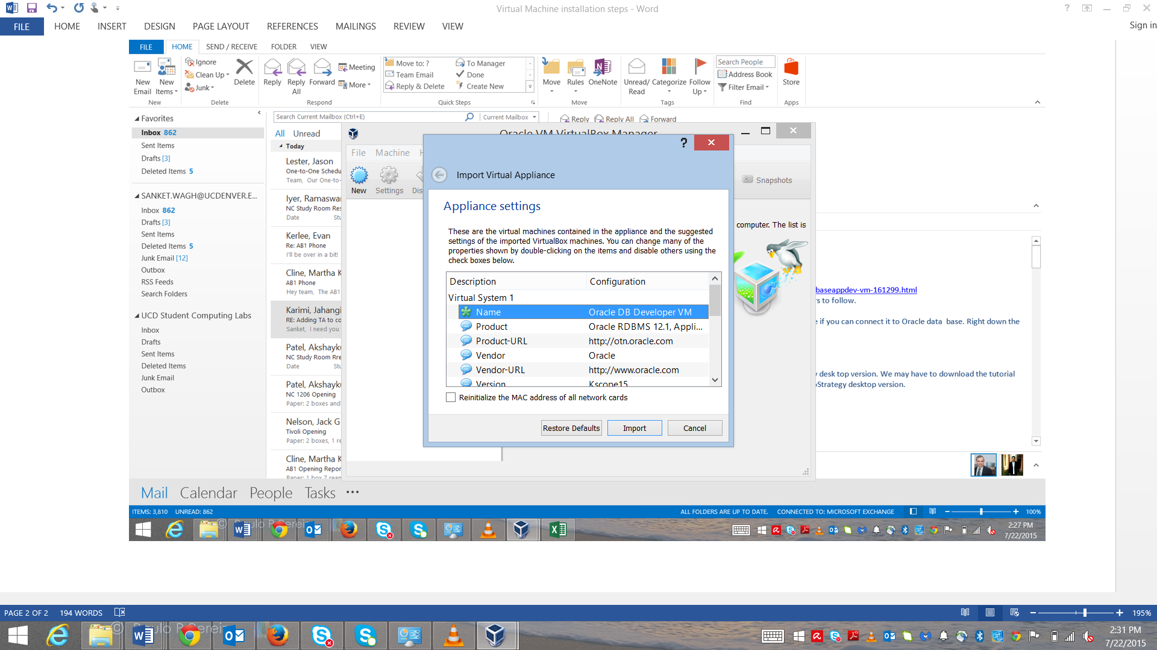

1. Wait till the process is complete.

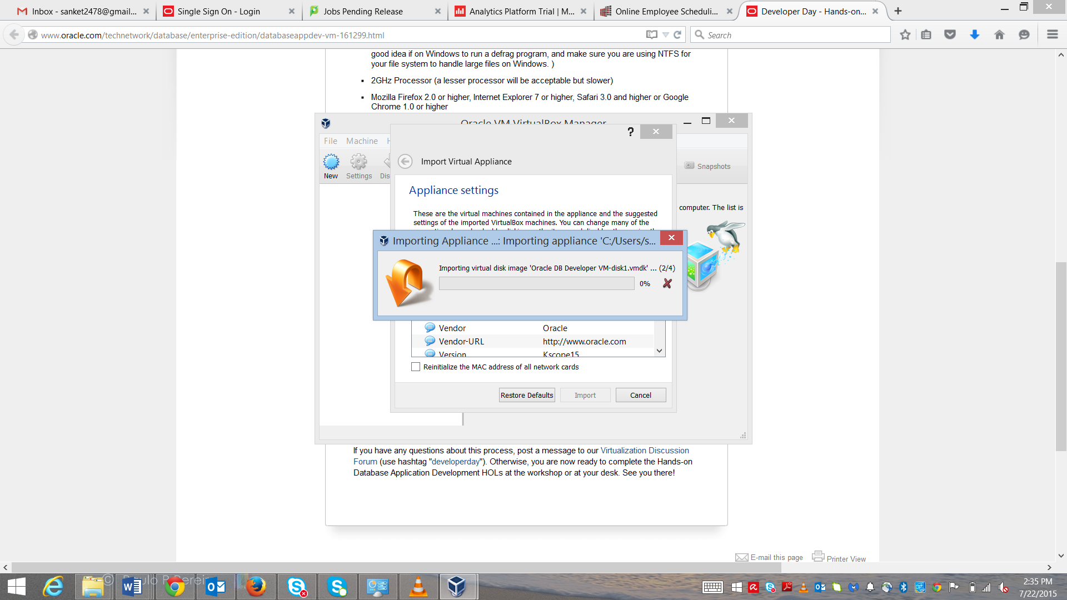

1. After the file is uploaded in the Virtual Machine, you will see a small “penguin” icon on the left. Click on it and then click on the “Start” icon on the top to start the virtual machine.

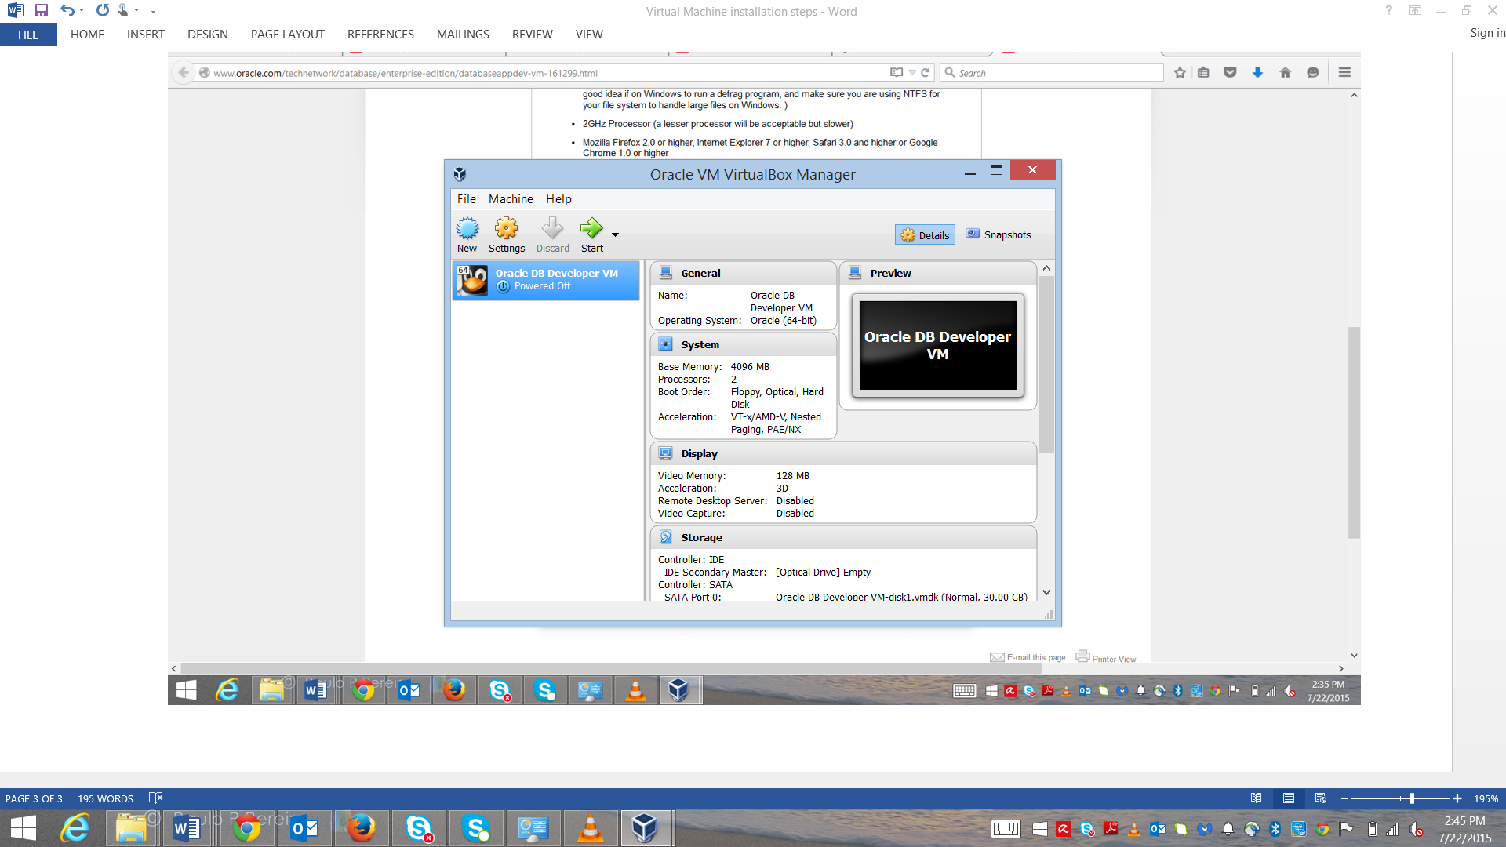

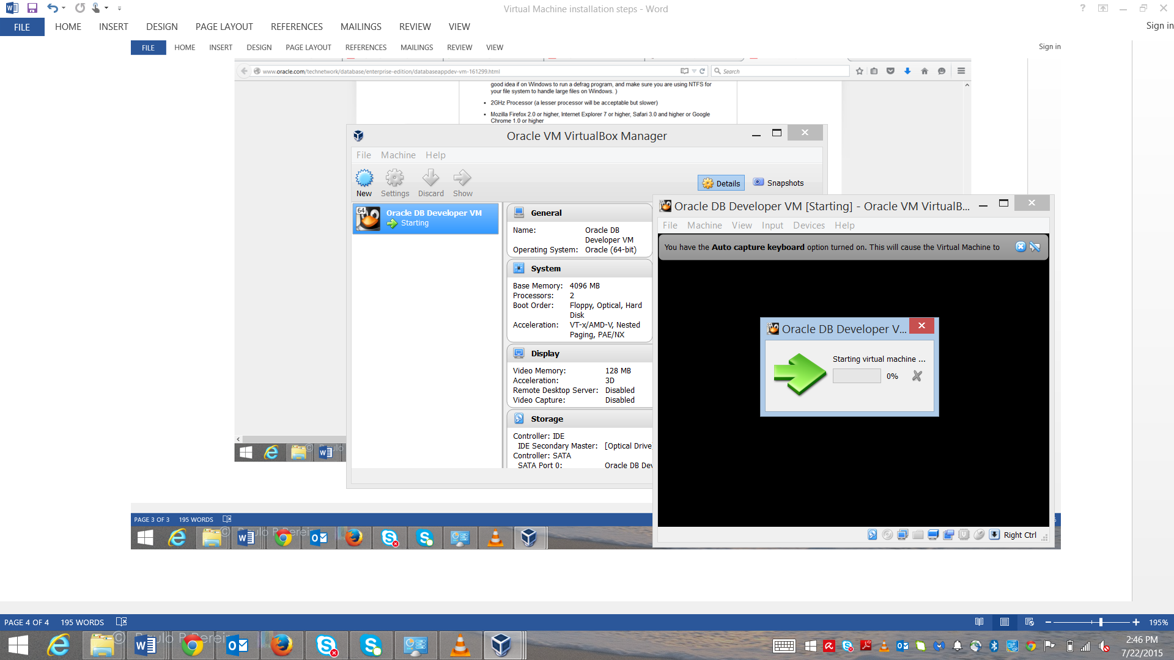

1. Allow access to private networks whenever required as this will allow smooth installation of Oracle VM to load all the required files in your directory.

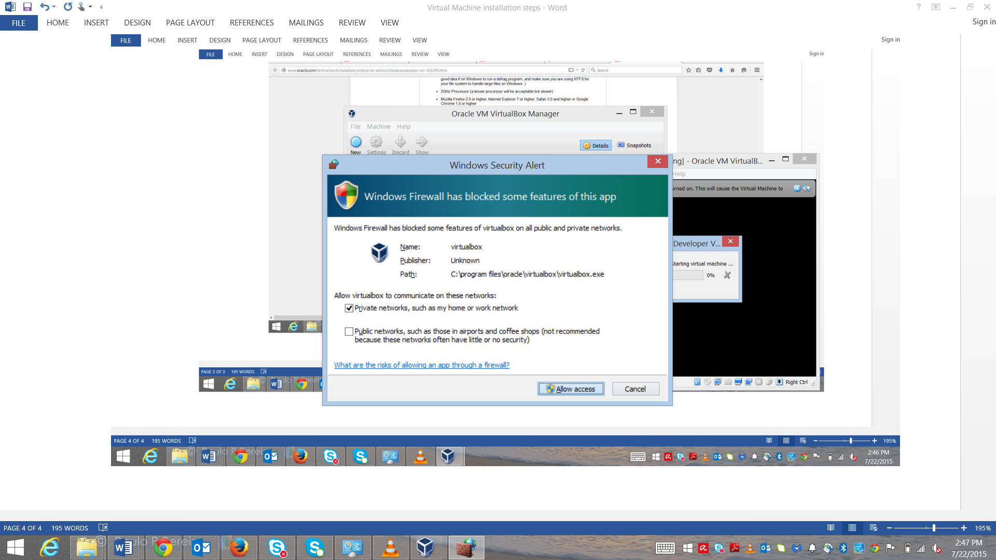



1. Once installation is complete you will be logged onto the Oracle VM which will be seen as shown in the below screenshot

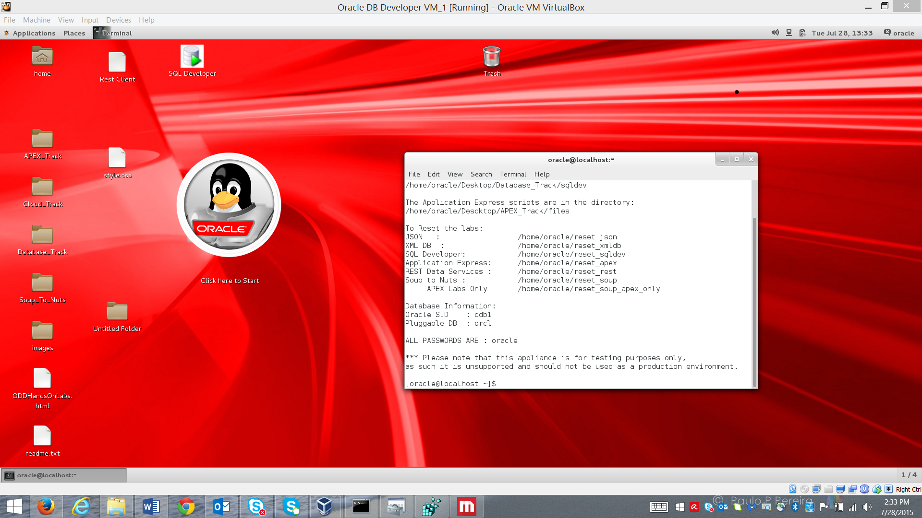

Inside this Linux box (white screen), check the ORACLE_HOME and ORACLE_SID path by using the following commands:

echo $ORACLE_HOME and echo $ORACLE_SID

It should be **ORACLE_HOME=/home/oracle/app/oracle/product/12.1.0/dbhome_1** and **ORACLE_SID=cdb1**

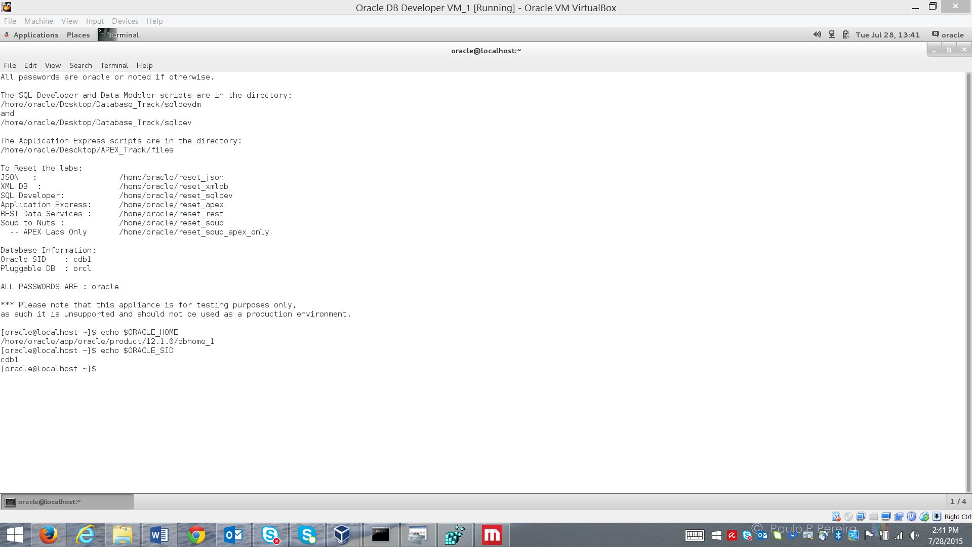

1. Try to connect to the database using the command:

sqlplus scott@orcl

password: tiger

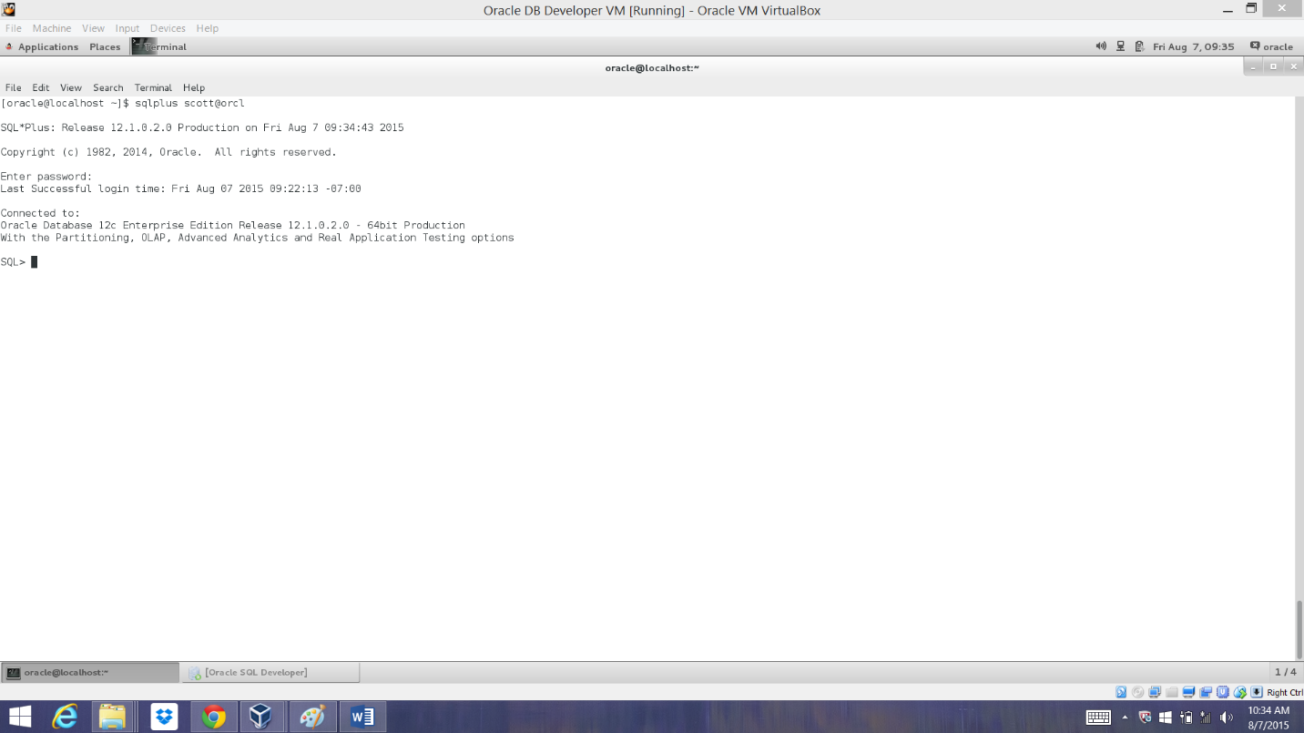And check if you can connect to the database. [Refer the below steps]

Type exit to return to the Unix prompt. This indicates that the Oracle VM is ready for connection with SQL Developer.

As an alternative to using the highly privileged SYS and SYSTEM users or the default user Scott, you can create a new user with DBA privileges.

* Connect to your database with SYS / SYSTEM (you can use SQL Developer or SQLplus for this).
* Create a new user with the following SQL statements, in this example, 'coursera' is the username and 'mypassword' is the password:

*CREATE USER coursera IDENTIFIED BY mypassword;*

*GRANT DBA to coursera;*

You can now disconnect your session and edit the database connection properties in SQL Developer. Change the username and password to the ones you specified at step 2. Reconnect again and you now have an empty schema. This new user has the DBA role so it is ideal for development.